**Introduction**

This report aims to find the difference in risk of temper control issues between those who are Vietnam war veterans and those who are veterans that did not serve in Vietnam. The question of if there is a difference in risk of temper control issues and if so, how much, will be addressed. To do this, the results of a 1979 survey containing data related to various post-traumatic stress order symptoms (PTSD), including temper control problems, from veterans who entered the service between 1965 and 1975 were analyzed.

**Data & Methods**

The data used for this report comes from a 1979 Verteran’s Administration (VA) survey conducted on veterans who entered the service between 1965 and 1975. After randomly selecting 1783 individuals from this population, the veterans were asked about various post-traumatic stress disorder (PTSD) symptoms, which included the presence of temper control issues. In addition, the VA collected data on what war the veterans served in. For this analysis, they were grouped in ‘Vietnam Veteran’ and ‘Veteran who did not serve in Vietnam’ statuses. To analyze this data, an odds ratio was calculated in R using the epi2x2 command from the epibasix library.

**Exploratory Data Analysis**

In order to perform statistical analysis, a table must first be constructed that summarizes the data presented. The data was initially presented in a paragraph format, which needed to be transformed into a 2x2 table. Of the 771 Vietnam veterans surveyed, 176 of them had temper control issues (table 1). Comparatively, of the 1012 Veterans who did not serve in Vietnam, only 144 had temper-control issues (table 1). A barplot was constructed from this data to visualize these numbers. It can be seen that of those with temper control issues, there are slightly more Vietnam veterans than veterans who did not serve in Vietnam (fig. A). Additionally, in those without temper control issues there are a great deal more veterans who did not serve in Vietnam than those who did (fig. A).

**Results**

An odds ratio is used to compare the likelihood of an event outcome between two groups. In this analysis, it is the likelihood of having temper control issues between Vietnam veterans and non-Vietnam veterans. An odds ratio was chosen as the method of analysis as this is a cross sectional study and it is recommended over the use of relative risk in such a case. The outcome of this odds ratio was 1.783. The 95% confidence interval is [1.397, 2.275]. This means that, based on the sample’s outcomes, there is a 95% likelihood that the true odds-ratio of the population is within that range. Additionally, because the confidence interval does not include one, the difference between the two groups is considered significant. This can be interpreted as Vietnam war veterans having nearly 80% higher odds of having temper-control issues than other veterans surveyed.

**Conclusion**

In summary, this report is 95% confident that the odds of having temper-control issues for Vietnam veterans are between 1.263 and 2.038 times the odds of having temper-control issues for veterans who did not serve in Vietnam. Given that the confidence interval is entirely larger than one, it can be concluded that the odds of vietnam veterans having temper control issues is significantly higher than their non-Vietnam veteran counterparts. In other terms, veterans of Vietnam are significantly more likely to develop temper control issues than other veterans who did not serve in Vietnam.

**Appendix**

**Figure A**

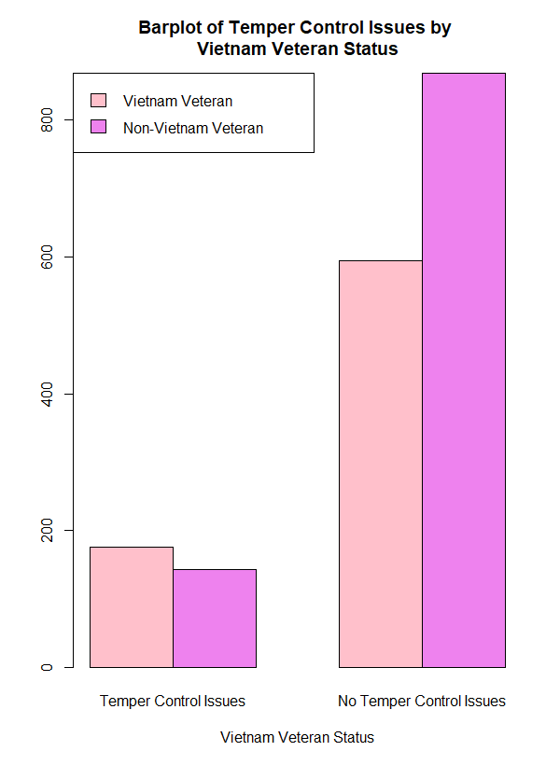

**Table 1**

|  | Temper-Control Issues | No Temper-Control Issues |
| --- | --- | --- |
| Vietnam Veteran | 176 | 595 |
| Other Veteran | 144 | 868 |